

**PRESS RELEASE** Prague, 20th October 2015

# Grand opening of DELTA building in BB Centrum

**PASSERINVEST GROUP, a leading Czech development and investment company, organised a gala evening on the occasion of the completion of the DELTA office building, the 17th project in the multifunctional BB Centrum complex in Prague - Michle. The DELTA building is the largest as well as the greenest building in BB Centrum and its main tenants are Hewlett-Packard and Microsoft.**

The motto of the evening was a fusion of nature and modern technology, which precisely fits the concept of the building itself. An interesting programme was prepared for the entire evening, including special lighting effects that emphasised the environs of the whole building and the unique water features. Participants in the gala event had an opportunity to visit the rooftop terrace, which measures almost 1900 m2 and to view the “Progress of the DELTA building construction” exhibit. The commented tour of the office spaces, including the Microsoft and Skype customer centre, also met with great interest.

*“We couldn’t have found a better opportunity for an informal gathering than this, the opening of our newest and largest building. I am glad that not only the tenants of BB Centrum, but all the guests could view Microsoft’s designer and non-traditional office spaces and relish the unique view from the DELTA building terrace. I hope that everybody was able to forget their day-to-day troubles, at least for a while, and enjoy a pleasant evening,”* commentedRadim Passer, the Chairman of the Board of Directors of PASSERINVEST GROUP, with regard to the grand opening.

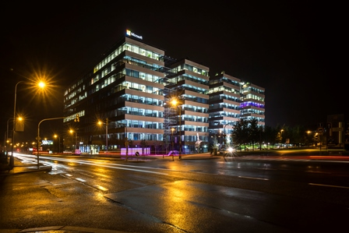

DELTA building in the BB Centrum

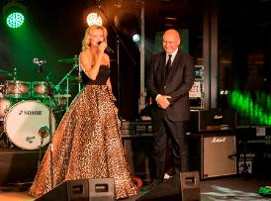

From left: presenter of the evening Kateřina Brožová handing over her word to Radim Passer, Chairman of the Board of Directors of PASSERINVEST GROUP, for his welcome speech

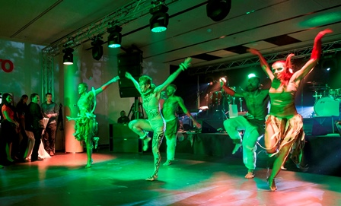

Dance performances of the “Projekt AWA” at the grand opening of the DELTA building

For more information and photographs in print quality please contact:

Mgr. Vendula Malochová**,** Marketing Manager

**PASSERINVEST GROUP, a.s.**

Tel.: (+420) 221 582 111, fax: (+420) 222 515 521

Mobil: (+420) 605 318 974

E-mail: [Vendula.Malochova@Passerinvest.cz](mailto:Vendula.Malochova@Passerinvest.cz)

www.passerinvest.cz, [www.bbcentrum.cz](http://www.bbcentrum.cz)

Ing. Marcela Štefcová

**Crest Communications a.s.**

Tel.: (+420) 222 927 125

Mobil: (+420) 731 613 669

E-mail: marcela.stefcova@crestcom.cz

**About the Developer**

**PASSERINVEST GROUP, a.s.,** founded in 1991 by Radim Passer, is a purely Czech development and investment company whose name is associated in particular with the **BB Centrum** multifunctional complex in Prague 4 - Michle. With this project, the most successful and extensive Czech project of its type, the company has built its excellent reputation both at home and at the international level. Contributing to this is not only the high quality of the projects completed to date, but also its high level of service, its sense of fair play, its positive relationship with the tenants and users of its buildings, and its sense of responsibility towards society and the environment. **PASSERINVEST GROUP**’sportfolioincludes other interesting development projects.